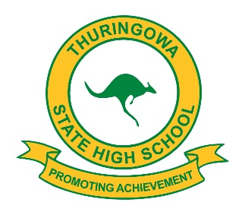
2026
THURINGOWA STATE HIGH SCHOOL
STUDENT LEADERS

2026 SCHOOL CAPTAINS
SCHOOL CAPTAIN | BLAKE SINGLETON
SCHOOL CAPTAIN | EMILY ROGERS
SCHOOL VICE-CAPTAIN | NICHOLAS REYNOLDS
SCHOOL VICE-CAPTAIN | CAYLEN BANN

2026 JUNIOR SCHOOL CAPTAINS
JUNIOR SCHOOL CAPTAIN | KOLOLITA TUITUPOU
JUNIOR SCHOOL CAPTAIN | JAYVIEN BANN

2026 INDIGENOUS LEADER
ATSI STUDENT LEADER | EMMERSON CUFF

2026 JUNIOR INDIGENOUS LEADER
JUNIOR ATSI STUDENT LEADER | JAYVIEN BANN

2026 SRC REPRESENTATIVES
YEAR 9 | MATILDA EILERS, AMY SIMPSON
YEAR 10 | ARIEH DUFFIN, ADDISON MCDOWALL
YEAR 12 | ALLEIGHA ILLIN, LORAINE MTENGEZANWA

2026 STUDENT REPRESENTATIVE COUNCIL
PRESIDENT | NICHOLAS REYNOLDS
VICE PRESIDENT | CAYLEN BANN
TREASURER | HAYLEY PHILLIS
SECRETARY | ZARAH CROUCH

2026 JUNIOR HOUSE CAPTAINS
BECK
DALE MIVAL, DYLAN PHILP
GOLLOGLY
ARIEH DUFFIN
GOULDIAN
KOLOLITA TUITUPOU, CHARLI MCKEAND-COBB

2026 SENIOR HOUSE CAPTAINS
BECK
LOGAN FOLDER, EMMERSON CUFF
GOLLOGLY
GEORGE SQUIRES, LORAINE MTENGEZANWA
GOULDIAN
JAYDEN TRUSCOTT
RIVERWAY
NJ DEVELOS, KADENCE DAWSON

